**CLUSTERING IN MACHINE LEARNING**

Clustering is a grouping of data points based on their similarity with each other is called Clustering or Cluster Analysis. This method is defined under the branch of Unsupervised Learning.

It does it by finding some similar patterns in the unlabelled dataset such as shape, size, color, behavior, etc., and divides them as per the presence and absence of those similar patterns.

It is an unsupervised learning method, hence no supervision is provided to the algorithm, and it deals with the unlabeled dataset.

After applying this clustering technique, each cluster or group is provided with a cluster-ID. ML system can use this id to simplify the processing of large and complex datasets.

The clustering technique is commonly used for statistical data analysis.

**Note: Clustering is somewhere similar to the classification algorithm, but the difference is the type of dataset that we are using. In classification, we work with the labeled data set, whereas in clustering, we work with the unlabelled dataset.**

**Example**: Let's understand the clustering technique with the real-world example of Mall: When we visit any shopping mall, we can observe that the things with similar usage are grouped together. Such as the t-shirts are grouped in one section, and trousers are at other sections, similarly, in vegetable sections, apples, bananas, Mangoes, etc., are grouped in separate sections, so that we can easily find out the things. The clustering technique also works in the same way

The clustering technique can be widely used in various tasks. Some most common uses of this technique are:

Market Segmentation – Businesses use clustering to group their customers and use targeted advertisements to attract more audience.

Market Basket Analysis – Shop owners analyze their sales and figure out which items are majorly bought together by the customers. For example, In USA, according to a study diapers and beers were usually bought together by fathers.

Social Network Analysis – Social media sites use your data to understand your browsing behavior and provide you with targeted friend recommendations or content recommendations.

Medical Imaging – Doctors use Clustering to find out diseased areas in diagnostic images like X-rays.

Anomaly Detection – To find outliers in a stream of real-time dataset or forecasting fraudulent transactions we can use clustering to identify them.

Simplify working with large datasets – Each cluster is given a cluster ID after clustering is complete. Now, you may reduce a feature set’s whole feature set into its cluster ID. Clustering is effective when it can represent a complicated case with a straightforward cluster ID. Using the same principle, clustering data can make complex datasets simpler.

**Types of Clustering Methods**

The clustering methods are broadly divided into **Hard clustering** (datapoint belongs to only one group) and **Soft Clustering** (data points can belong to another group also). But there are also other various approaches of Clustering exist. Below are the main clustering methods used in Machine learning:

1. Partitioning Clustering
2. Density-Based Clustering
3. Distribution Model-Based Clustering
4. Hierarchical Clustering
5. Fuzzy Clustering

**Partitioning Clustering**

Partitioning methods are the easiest clustering algorithms. They group data points on the basis of their closeness. Generally, the similarity measures chosen for these algorithms are Euclidean distance, Manhattan Distance or Minkowski Distance. The datasets are separated into a predetermined number of clusters, and each cluster is referenced by a vector of values. When compared to the vector value, the input data variable shows no difference and joins the cluster.

The primary drawback for these algorithms is the requirement that we establish the number of clusters, “k,” either intuitively or scientifically (using the Elbow Method) before any clustering machine learning system starts allocating the data points. Despite this, it is still the most popular type of clustering. K-means and K-medoids clustering are some examples of this type of clustering

**Density-Based Clustering**

The density-based clustering method connects the highly-dense areas into clusters, and the arbitrarily shaped distributions are formed as long as the dense region can be connected. This algorithm does it by identifying different clusters in the dataset and connects the areas of high densities into clusters. The dense areas in data space are divided from each other by sparser areas.

These algorithms can face difficulty in clustering the data points if the dataset has varying densities and high dimensions.

.

**Distribution Model-Based Clustering**

In the distribution model-based clustering method, the data is divided based on the probability of how a dataset belongs to a particular distribution. The grouping is done by assuming some distributions, commonly Gaussian Distribution.

The example of this type is the Expectation-Maximization Clustering algorithm that uses Gaussian Mixture Models (GMM).

**Hierarchical Clustering**

Hierarchical clustering can be used as an alternative for the partitioned clustering as there is no requirement of pre-specifying the number of clusters to be created. In this technique, the dataset is divided into clusters to create a tree-like structure, which is also called a dendrogram. The observations or any number of clusters can be selected by cutting the tree at the correct level. The most common example of this method is the Agglomerative Hierarchical algorithm.

**Fuzzy Clustering**

Fuzzy clustering is a type of soft method in which a data object may belong to more than one group or cluster. Each dataset has a set of membership coefficients, which depend on the degree of membership to be in a cluster. Fuzzy C-means algorithm is the example of this type of clustering; it is sometimes also known as the Fuzzy k-means algorithm.

**Clustering algorithms that are widely used in machine learning:**

1. **K-Means algorithm:** The k-means algorithm is one of the most popular clustering algorithms. It classifies the dataset by dividing the samples into different clusters of equal variances. The number of clusters must be specified in this algorithm. It is fast with fewer computations required, with the linear complexity of O(n).
2. **Mean-shift algorithm:** Mean-shift algorithm tries to find the dense areas in the smooth density of data points. It is an example of a centroid-based model that works on updating the candidates for centroid to be the center of the points within a given region.
3. **DBSCAN Algorithm:** It stands for Density-Based Spatial Clustering of Applications with Noise. It is an example of a density-based model similar to the mean-shift, but with some remarkable advantages. In this algorithm, the areas of high density are separated by the areas of low density. Because of this, the clusters can be found in any arbitrary shape
4. **Expectation-Maximization Clustering using GMM:** This algorithm can be used as an alternative for the k-means algorithm or for those cases where K-means can be failed. In GMM, it is assumed that the data points are Gaussian distributed.
5. **Agglomerative Hierarchical algorithm:** The Agglomerative hierarchical algorithm performs the bottom-up hierarchical clustering. In this, each data point is treated as a single cluster at the outset and then successively merged. The cluster hierarchy can be represented as a tree-structure.
6. **Affinity Propagation:** It is different from other clustering algorithms as it does not require to specify the number of clusters. In this, each data point sends a message between the pair of data points until convergence. It has O(N2T) time complexity, which is the main drawback of this algorithm.

**K-Means Clustering Algorithm**

K-Means Clustering is an Unsupervised Learning algorithm, which groups the unlabeled dataset into different clusters. Here K defines the number of predefined clusters that need to be created in the process, as if K=2, there will be two clusters, and for K=3, there will be three clusters, and so on.

Note : It is an iterative algorithm that divides the unlabeled dataset into k different clusters in such a way that each dataset belongs to only one group that has similar properties.

It allows us to cluster the data into different groups and a convenient way to discover the categories of groups in the unlabeled dataset on its own without the need for any training.

It is a centroid-based algorithm, where each cluster is associated with a centroid. The main aim of this algorithm is to minimize the sum of distances between the data point and their corresponding clusters.

The algorithm takes the unlabeled dataset as input, divides the dataset into k-number of clusters, and repeats the process until it does not find the best clusters. The value of k should be predetermined in this algorithm.

**The k-means clustering algorithm mainly performs two tasks:**

Determines the best value for K center points or centroids by an iterative process.

Assigns each data point to its closest k-center. Those data points which are near to the particular k-center, create a cluster.

Hence each cluster has data points with some commonalities, and it is away from other clusters.

The below diagram explains the working of the K-means Clustering Algorithm:

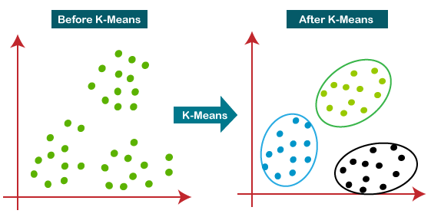

**How does the K-Means Algorithm Work?**

The working of the K-Means algorithm is explained in the below steps:

**Step-1:** Select the number K to decide the number of clusters.

**Step-2:** Select random K points or centroids. (It can be other from the input dataset).

**Step-3:** Assign each data point to their closest centroid, which will form the predefined K clusters.

**Step-4:** Calculate the variance and place a new centroid of each cluster.

**Step-5:** Repeat the third steps, which means reassign each datapoint to the new closest centroid of each cluster.

**Step-6:** If any reassignment occurs, then go to step-4 else go to FINISH.

**Step-7:** The model is ready.

Let's understand the above steps by considering the visual plots:

Suppose we have two variables M1 and M2. The x-y axis scatter plot of these two variables is given below:

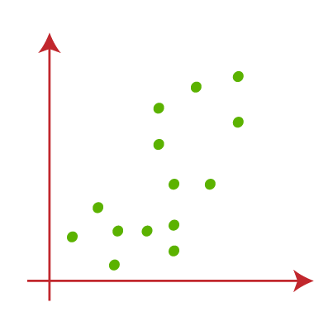

* Let's take the number k of clusters, i.e., K=2, to identify the dataset and to put them into different clusters. It means here we will try to group these datasets into two different clusters.
* We need to choose some random k points or centroid to form the cluster. These points can be either the points from the dataset or any other point. So, here we are selecting the below two points as k points, which are not the part of our dataset. Consider the below image:

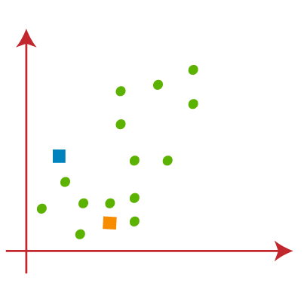

* Now we will assign each data point of the scatter plot to its closest K-point or centroid. We will compute it by applying some mathematics that we have studied to calculate the distance between two points. So, we will draw a median between both the centroids. Consider the below image:

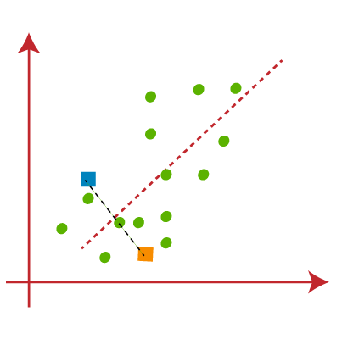

* From the above image, it is clear that points on the left side of the line are near to the K1 or blue centroid, and points to the right of the line are close to the yellow centroid. Let's color them as blue and yellow for clear visualization.

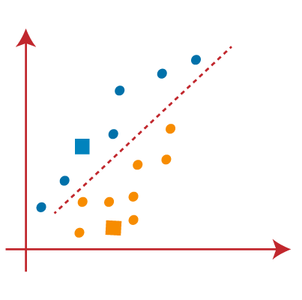

* As we need to find the closest cluster, so we will repeat the process by choosing a new centroid. To choose the new centroids, we will compute the center of gravity of these centroids, and will find new centroids as below:

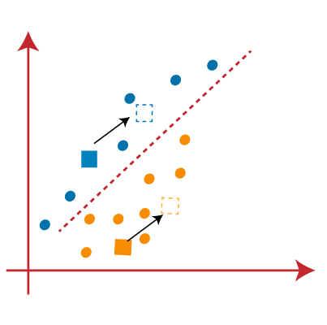

* Next, we will reassign each datapoint to the new centroid. For this, we will repeat the same process of finding a median line. The median will be like below image:

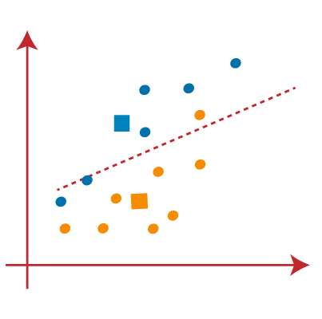

* From the above image, we can see, one yellow point is on the left side of the line, and two blue points are right to the line. So, these three points will be assigned to new centroids.

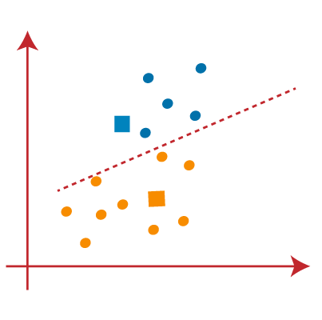

As reassignment has taken place, so we will again go to the step-4, which is finding new centroids or K-points.

* We will repeat the process by finding the center of gravity of centroids, so the new centroids will be as shown in the below image:

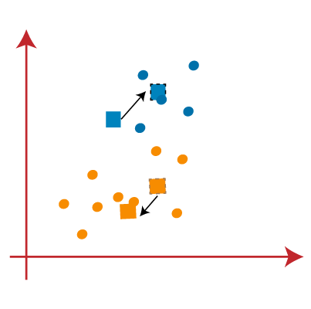

* As we got the new centroids so again will draw the median line and reassign the data points. So, the image will be:

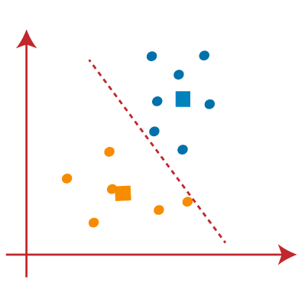

* We can see in the above image; there are no dissimilar data points on either side of the line, which means our model is formed. Consider the below image:

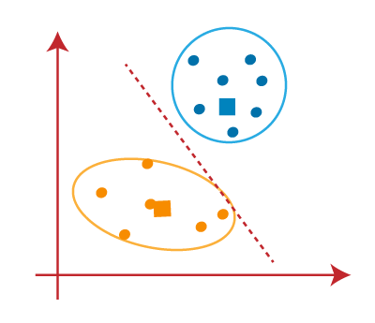

As our model is ready, so we can now remove the assumed centroids, and the two final clusters will be as shown in the below image:

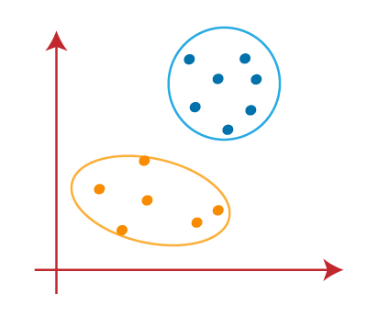

**How to choose the value of "K number of clusters" in K-means Clustering?**

**Elbow Method**

The Elbow method is one of the most popular ways to find the optimal number of clusters. This method uses the concept of WCSS value. WCSS stands for Within Cluster Sum of Squares, which defines the total variations within a cluster. The formula to calculate the value of WCSS (for 3 clusters) is given below:

**WCSS= ∑Pi in Cluster1 distance(Pi C1)2 +∑Pi in Cluster2distance(Pi C2)2+∑Pi in CLuster3 distance(Pi C3)2**

In the above formula of WCSS,

∑Pi in Cluster1 distance(Pi C1)2: It is the sum of the square of the distances between each data point and its centroid within a cluster1 and the same for the other two terms.

To measure the distance between data points and centroid, we can use any method such as Euclidean distance or Manhattan distance.

To find the optimal value of clusters, the elbow method follows the below steps:

* It executes the K-means clustering on a given dataset for different K values (ranges from 1-10).
* For each value of K, calculates the WCSS value.
* Plots a curve between calculated WCSS values and the number of clusters K.
* The sharp point of bend or a point of the plot looks like an arm, then that point is considered as the best value of K.

Since the graph shows the sharp bend, which looks like an elbow, hence it is known as the elbow method. The graph for the elbow method looks like the below image:

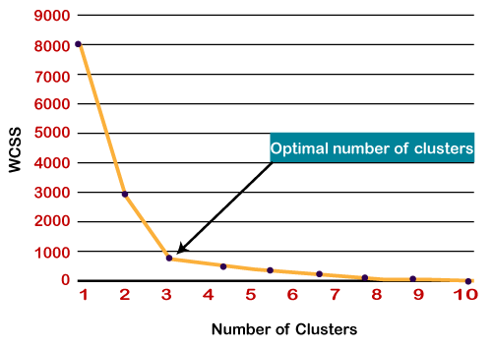

**Note: We can choose the number of clusters equal to the given data points. If we choose the number of clusters equal to the data points, then the value of WCSS becomes zero, and that will be the endpoint of the plot.**

**Hierarchical Clustering in Machine Learning**

Hierarchical clustering is another unsupervised machine learning algorithm, which is used to group the unlabeled datasets into a cluster and also known as **hierarchical cluster analysis** or HCA.

In this algorithm, we develop the hierarchy of clusters in the form of a tree, and this tree-shaped structure is known as the **dendrogram**.

Sometimes the results of K-means clustering and hierarchical clustering may look similar, but they both differ depending on how they work. As there is no requirement to predetermine the number of clusters as we did in the K-Means algorithm.

The hierarchical clustering technique has two approaches:

1. **Agglomerative**: Agglomerative is a bottom-up approach, in which the algorithm starts with taking all data points as single clusters and merging them until one cluster is left.
2. **Divisive**: Divisive algorithm is the reverse of the agglomerative algorithm as it is a top-down approach.

**Agglomerative Hierarchical clustering**

The agglomerative hierarchical clustering algorithm is a popular example of HCA. To group the datasets into clusters, it follows the **bottom-up approach**. It means, this algorithm considers each dataset as a single cluster at the beginning, and then start combining the closest pair of clusters together. It does this until all the clusters are merged into a single cluster that contains all the datasets.

This hierarchy of clusters is represented in the form of the dendrogram.

**How the Agglomerative Hierarchical clustering Work?**

The working of the AHC algorithm can be explained using the below steps:

**Step-1:** Create each data point as a single cluster. Let's say there are N data points, so the number of clusters will also be N.

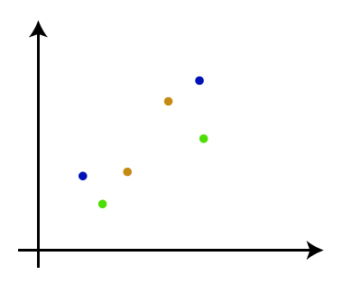

**Step-2:** Take two closest data points or clusters and merge them to form one cluster. So, there will now be N-1 clusters.

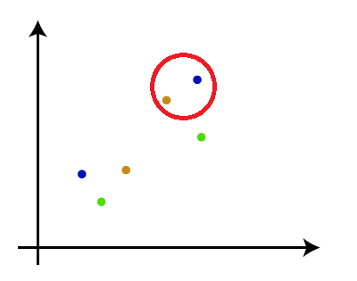

**Step-3**: Again, take the two closest clusters and merge them together to form one cluster. There will be N-2 clusters.

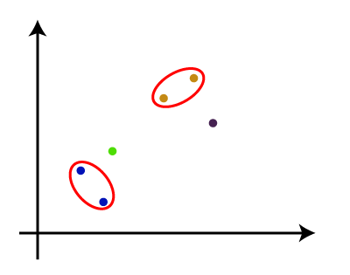

**Step-4**: Repeat Step 3 until only one cluster left. So, we will get the following clusters. Consider the below images:

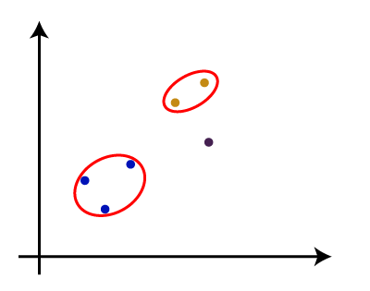

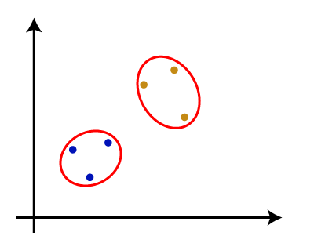

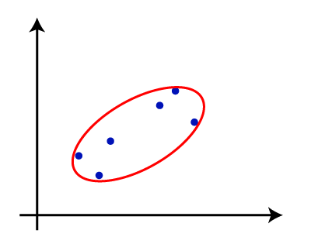

**Step-5**: Once all the clusters are combined into one big cluster, develop the dendrogram to divide the clusters as per the problem.

**Note: To better understand hierarchical clustering, it is advised to have a look on k-means clustering**

**Measure for the distance between two clusters**

As we have seen, the **closest distance** between the two clusters is crucial for hierarchical clustering. There are various ways to calculate the distance between two clusters, and these ways decide the rule for clustering. These measures are called **Linkage methods**. Some of the popular linkage methods are given below:

1. **Single Linkage**: It is the Shortest Distance between the closest points of the clusters. Consider the below image:

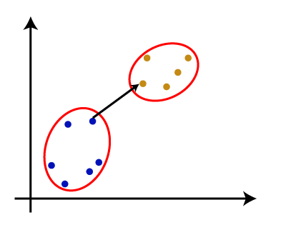

1. **Complete Linkage**: It is the farthest distance between the two points of two different clusters. It is one of the popular linkage methods as it forms tighter clusters than single-linkage.

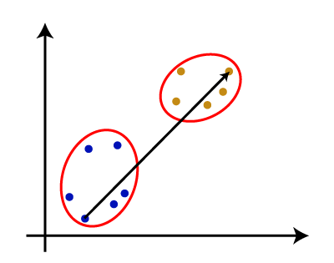

1. **Average Linkage**: It is the linkage method in which the distance between each pair of datasets is added up and then divided by the total number of datasets to calculate the average distance between two clusters. It is also one of the most popular linkage methods.
2. **Centroid Linkage**: It is the linkage method in which the distance between the centroid of the clusters is calculated. Consider the below image:

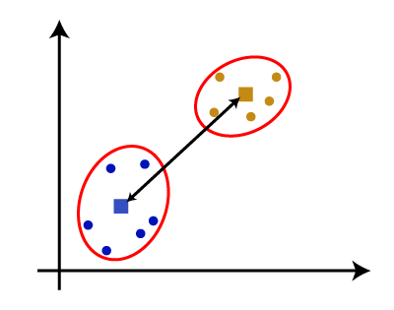

From the above-given approaches, we can apply any of them according to the type of problem or business requirement.

**Woking of Dendrogram in Hierarchical clustering**

The dendrogram is a tree-like structure that is mainly used to store each step as a memory that the HC algorithm performs. In the dendrogram plot, the Y-axis shows the Euclidean distances between the data points, and the x-axis shows all the data points of the given dataset.

The working of the dendrogram can be explained using the below diagram:

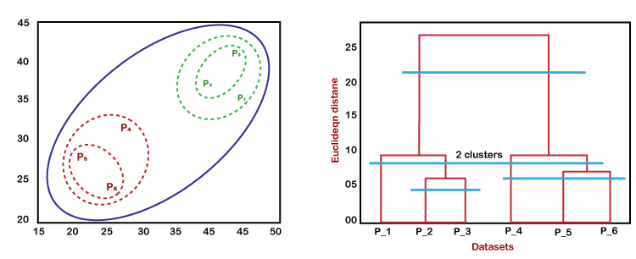

In the above diagram, the left part is showing how clusters are created in agglomerative clustering, and the right part is showing the corresponding dendrogram.

* As we have discussed above, firstly, the datapoints P2 and P3 combine together and form a cluster, correspondingly a dendrogram is created, which connects P2 and P3 with a rectangular shape. The hight is decided according to the Euclidean distance between the data points.
* In the next step, P5 and P6 form a cluster, and the corresponding dendrogram is created. It is higher than of previous, as the Euclidean distance between P5 and P6 is a little bit greater than the P2 and P3.
* Again, two new dendrograms are created that combine P1, P2, and P3 in one dendrogram, and P4, P5, and P6, in another dendrogram.
* At last, the final dendrogram is created that combines all the data points together.

We can cut the dendrogram tree structure at any level as per our requirement.